**INSTALLATION PROCESS OF OS/2**

|  |  |
| --- | --- |
| NAME | RAVELLA ABHINAV |
| ROLL No. | CB.EN.U4CSE19453 |

1. **Boot Screen :**

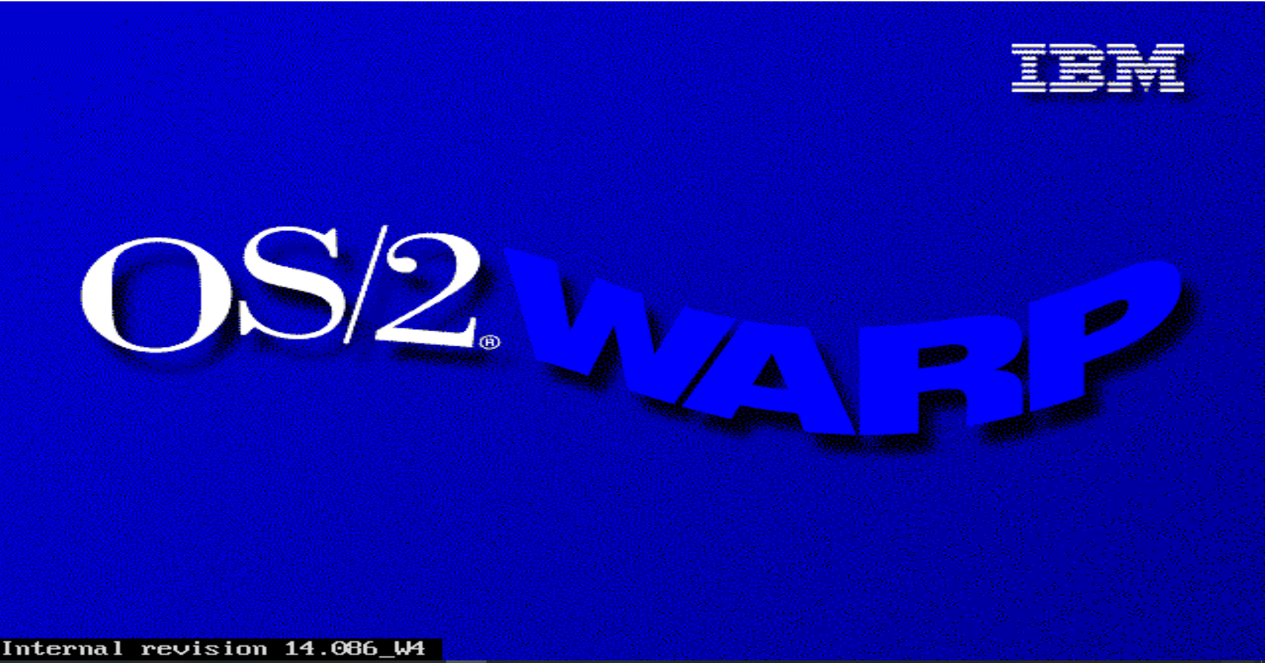

1. **Disc Change :**

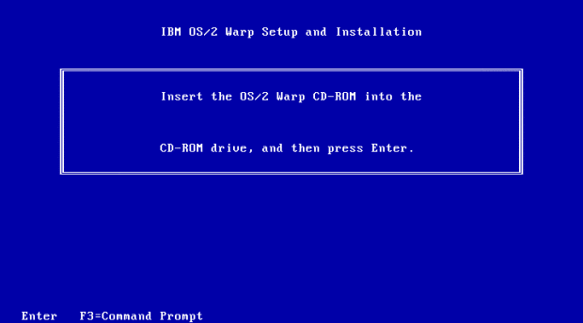

1. **Disk Partition Tool :**

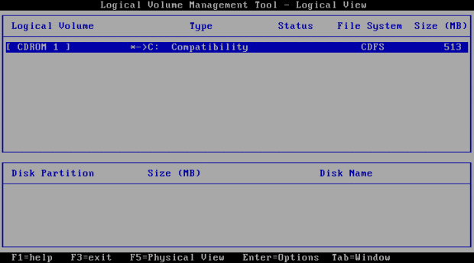

1. **Partitioning new disk :**

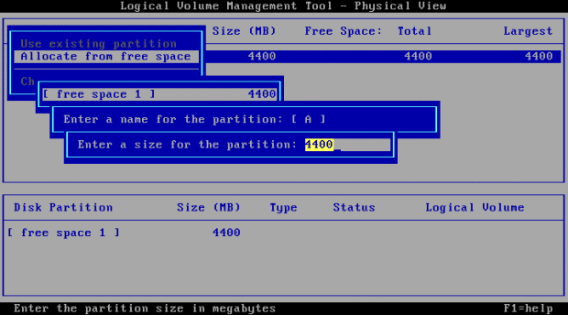

1. **Graphical installer -configuration :**

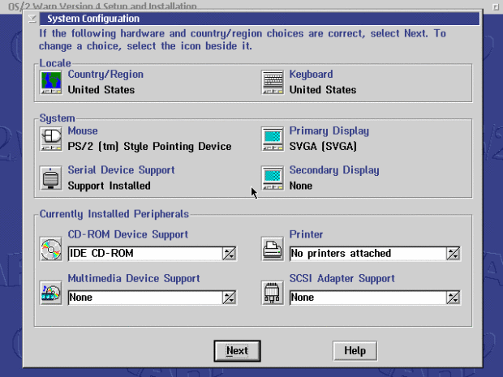

1. **Choosing Features :**

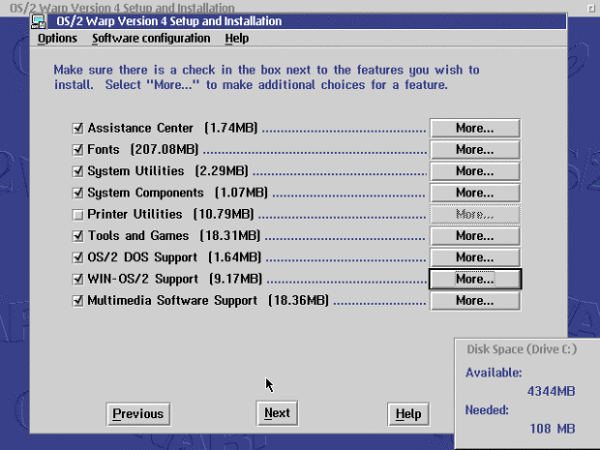

1. **Improving The Display :**

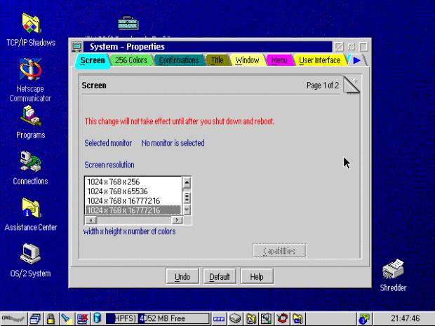

1. **Final Desktop :**

